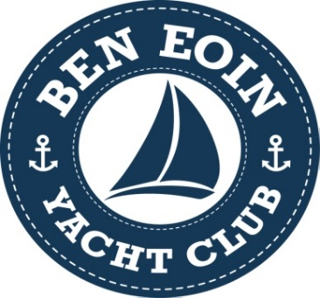

East Bay Regatta
BEYC Annual Regatta
Notice Of Race (NOR)

Date: July 29 – July 31, 2022

Location: BEYC, East Bay

Notice of Race Rules: The Regatta will be governed by the Racing Rules of Sailing (RRS). The rules of PHRF-NS will apply to handicap fleets.

Eligibility: The Regatta is open to boats with a current PHRF-NS Yacht Data Sheet for handicap racing. The race committee may extend the eligibility to boats without a PHRF-NS Yacht Data Sheet by assigning a provisional rating for use in this regatta only. The person in charge (ordinarily, but not necessarily the entrant) shall meet the requirements of Rule 46 and the Sail Canada prescription thereto.

Classes: Handicap racing on a time on time basis, with the fleet split to be determined by spinnaker and non-spinnaker class with fore and aft sails only. Once registered, the vessel cannot change their class designation.

Races: Up to 3 races are scheduled for handicap classes.

Scoring: One race is required to constitute a series. All races will count in handicap classes.

Registration: Registration will be at BEYC as per schedule below.
Per vessel including skipper ($50.00) (includes Saturday supper, 2 beverage tickets)
Crew passes ($30.00) (includes Saturday supper, 2 beverage tickets)

Insurance: Each participating boat shall be insured with 3rd party liability insurance with a minimum coverage of $1,000,000 per event or equivalent.

Continued …/

NOR SCHEDULE

Friday July 29th
- 12:00 – 14:00 Registration
- 15:00 Skippers Meeting
- 16:00 Race 1, First Warning

Saturday July 30th
- 12:00 Skippers Meeting
- 13:00 Race 2, First Warning

Sunday July 31st
- 12:00 Skippers Meeting
- 13:00 Race 3, First Warning
- 16:30 Meal
- 17:00 Awards and Presentation of Trophies

Food Service
- Friday July 29 Regular BEYC Social
- Sunday July 31 Food and Beverage Service after Race

Dock Space: A limited number of slips are available for vessels and registered and participating in the Regatta. Vessels must race in order to qualify for the free dockage. Additional slips are available for other visiting vessels. Please contact Club for more information.

BEYC Clubhouse: (902) 828-1099
BEYC Manager: manager@beneoinmarina.com

Ben Eoin Marina
4950 East Bay Highway, East Bay, Cape Breton
www.beneionmarina.com

